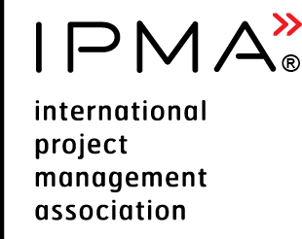 | Executive Summary Report  for IPMA Level A or B candidate, Programme Management | 

Executive Summary Report
for IPMA Level A or b candidate,
PROGRAMME MANAGEMENT

Podgorica 2025

Purpose
The purpose of this document is to provide directions how to prepare executive summary report for IPMA level A or B candidate working in programme management.
Candidate Name |  | Insert link to your CV
Level Applied for (check one) | IPMA Level A | IPMA Level B
Description of employer’s organisation
Organisation name:
Number of employees | < 250 | 250 – 5000 | > 5000
Main line of organisation’s industry | E.g. software development, banking
Main line of your programme industry
Role of applicant within employer’s organisation
An organisation chart with applicant position identified
Area of responsibility
An overview of the programme management processes / procedures used

Summary for all programmes
Name of the programme | Programme start date | Programme finish date | Duration, months | Score of complexity
Programme #1
Programme #2
Programme #3
Add more lines if applicable

Summary of the programme #1
Strategical benefit of the programme for the organisation | Describe the main benefits and deliverables of the programme
Time period of programme and projects within programme | Programme time period: xx.xx.xxxx - xx.xx.xxxx  Project 1 xx.xx.xxxx - xx.xx.xxxx  Project 2 xx.xx.xxxx - xx.xx.xxxx  Project 3 xx.xx.xxxx - xx.xx.xxxx  Project 4 xx.xx.xxxx - xx.xx.xxxx  Project 5 xx.xx.xxxx - xx.xx.xxxx
Management effort | Total no of menmonths of management/ total number of menmonths of execution
Total budget
Resources available | Personnel :  - No of persons involved into programme management  - No of persons total (peak) in the projects  - No of persons reporting to you
Contractors | - No of contractors  - No of subcontractors
Stakeholders | Relationship with internal and external stakeholders
Description of programme management | Describe the programme management organisation.  Describe the methods, tools, techniques and documents used.
Description of programme challenges | Describe how you have managed programme and how you met the complexity criteria. You can use the STAR approach (Situation, Task, Action, Result) in order to structure the report.  - Situation/challenge  - Effort to deal with it  - Outcome  - Reference to CEs  You can include the links to the information in complexity criteria form

Please copy and fill in relevant parts of this report accordingly to cover your experience.

